DESCRETE MATHEMATICS

UNIT- 5

1. PIGEON HOLE PRINCIPLE

ANS – WATCH THIS VIDEO WITH EXAMPLE

https://www.youtube.com/watch?v=3UeHl3UtmGI

2. EULAR GRAPH, PATH, CIRCUIT

ANS - https://www.youtube.com/watch?v=FoiLXsV-bnI

3. HAMILTON GRAPH

ANS - https://www.youtube.com/watch?v=GiClUAJMMtw

4. GRAPH COLORING, chromatic number

ANS - https://www.youtube.com/watch?v=FhXDhUAhHfE

5. ISOMORPHISM

ANS - https://www.youtube.com/watch?v=D-NK7rg6E_k

6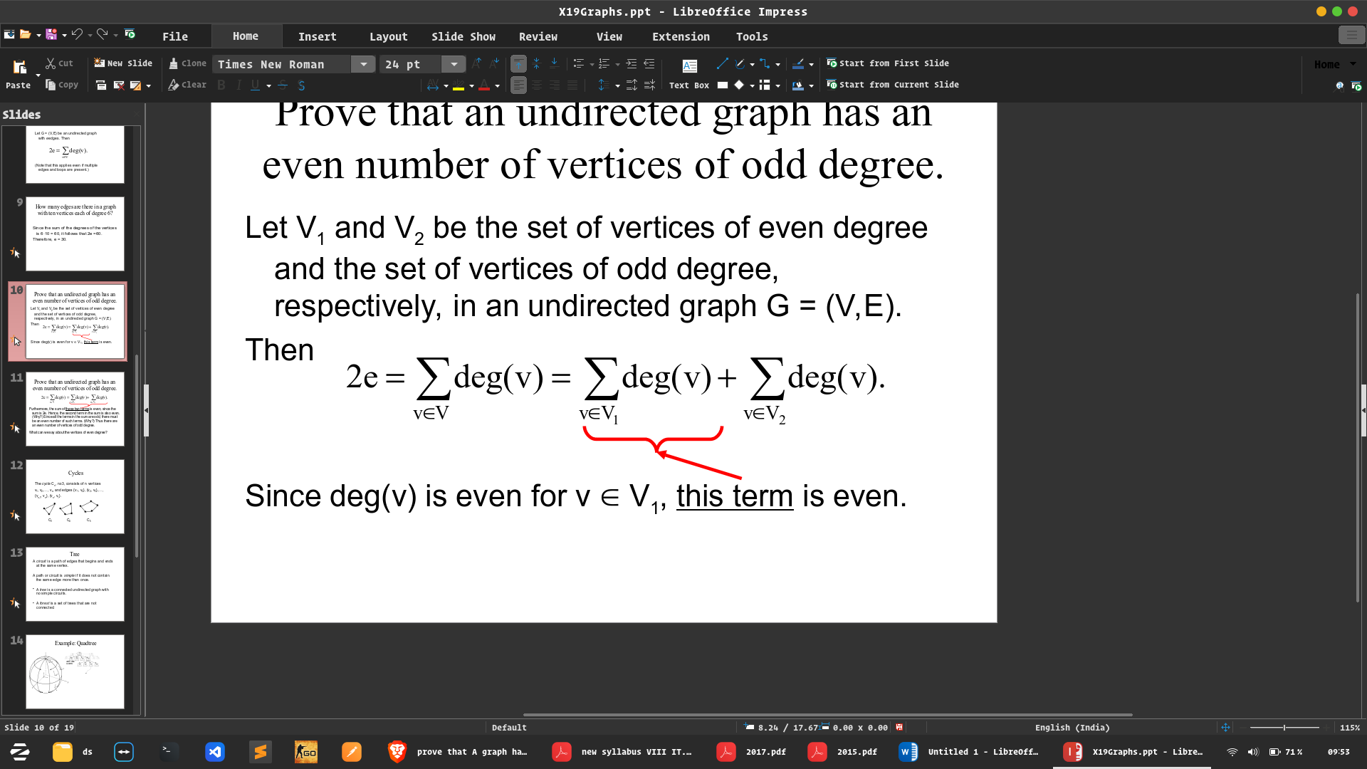. question

UNIT - 4

1. EXPLAIN BOOLEAN ALGEBRA. STATE AND PROVE DEMORGAN THEOREM

ANS - Boolean algebra is the category of algebra in which the variable’s values are the truth values, true and false, ordinarily denoted 1 and 0 respectively. It is used to analyze and simplify digital circuits or digital gates. It is also called Binary Algebra or logical Algebra.

## Boolean Algebra Operations

The basic operations of Boolean algebra are as follows:

* Conjunction or AND operation
* Disjunction or OR operation
* Negation or Not operation

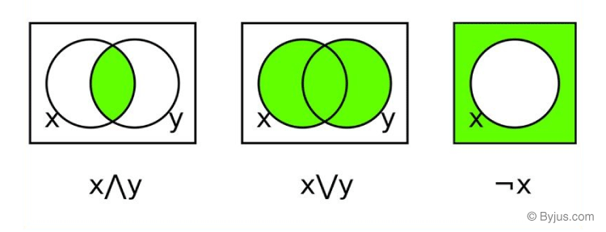

Below is the table defining the symbols for all three basic operations.

|  |  |  |
| --- | --- | --- |
| **Operator** | **Symbol** | **Precedence** |
| NOT | ‘ (or) ¬ | Highest |
| AND | . (or) ∧ | Middle |
| OR | + (or) ∨ | Lowest |

Suppose A and B are two Boolean variables, then we can define the three operations as;

* A conjunction B or A AND B, satisfies A ∧ B = True, if A = B = True or else A ∧ B = False.
* A disjunction B or A OR B, satisfies A ∨ B = False, if A = B = False, else A ∨ B = True.
* Negation A or ¬A satisfies ¬A = False, if A = True and ¬A = True if A = False

## Laws of Boolean Algebra

There are six types of [Boolean algebra laws](https://byjus.com/maths/boolean-algebra-laws/). They are:

* Commutative law
* Associative law
* Distributive law
* AND law
* OR law
* Inversion law

Those six laws are explained in detail here.

### Commutative Law

Any binary operation which satisfies the following expression is referred to as a commutative operation. Commutative law states that changing the sequence of the variables does not have any effect on the output of a logic circuit.

* A. B = B. A
* A + B = B + A

### Associative Law

It states that the order in which the logic operations are performed is irrelevant as their effect is the same.

* ( A. B ). C = A . ( B . C )
* ( A + B ) + C = A + ( B + C)

### Distributive Law

Distributive law states the following conditions:

* A. ( B + C) = (A. B) + (A. C)
* A + (B. C) = (A + B) . ( A + C)

### AND Law

These laws use the AND operation. Therefore they are called AND laws.

* A .0 = 0
* A . 1 = A
* A. A = A

### OR Law

These laws use the OR operation. Therefore they are called OR laws.

* A  + 0 = A
* A + 1 = 1
* A + A = A

### Inversion Law

In Boolean algebra, the inversion law states that double inversion of variable results in the original variable itself.

## Boolean Algebra Theorems

The two important theorems which are extremely used in Boolean algebra are De Morgan’s First law and De Morgan’s second law. These two theorems are used to change the Boolean expression. This theorem basically helps to reduce the given Boolean expression in the simplified form. These two De Morgan’s laws are used to change the expression from one form to another form. Now, let us discuss these two theorems in detail.

**De Morgan’s First Law:**

De Morgan’s First Law states that  (A.B)’ = A’+B’.

The first law states that the complement of the product of the variables is equal to the sum of their individual complements of a variable.

The truth table that shows the verification of De Morgan’s First law is given as follows:

|  |  |  |  |  |  |
| --- | --- | --- | --- | --- | --- |
| **A** | **B** | **A’** | **B’** | **(A.B)’** | **A’+B’** |
| 0 | 0 | 1 | 1 | 1 | 1 |
| 0 | 1 | 1 | 0 | 1 | 1 |
| 1 | 0 | 0 | 1 | 1 | 1 |
| 1 | 1 | 0 | 0 | 0 | 0 |

The last two columns show that (A.B)’ = A’+B’.

Hence, De Morgan’s First Law is proved.

**De Morgan’s Second Law:**

De Morgan’s Second law states that (A+B)’ = A’. B’.

The second law states that the complement of the sum of variables is equal to the product of their individual complements of a variable.

The following truth table shows the proof for De Morgan’s second law.

|  |  |  |  |  |  |
| --- | --- | --- | --- | --- | --- |
| **A** | **B** | **A’** | **B’** | **(A+B)’** | **A’. B’** |
| 0 | 0 | 1 | 1 | 1 | 1 |
| 0 | 1 | 1 | 0 | 0 | 0 |
| 1 | 0 | 0 | 1 | 0 | 0 |
| 1 | 1 | 0 | 0 | 0 | 0 |

The last two columns show that (A+B)’ = A’. B’.

Hence, De Morgan’s second law is proved.

2. CYCLIC MONOID OR CYCLIC GROUP OR GENERATOR QUESTION

ANS - https://www.youtube.com/watch?v=yevF2hxzpjU

3. WHAT IS MONOID?

ANS - https://www.youtube.com/watch?v=BnnivEZi3dU

4. RING

ANS - https://www.youtube.com/watch?v=nL1jOHXgvSQ